Eclipse Installation

**Big Ideas  
Tools and technologies can be adapted for specific purposes.**

As you begin your journey in this course, think carefully about the tools you use to program. A carpenter, a bricklayer, a painter… all of these people need tools in order to create and build. In much the same way, a computer programmer requires tools to create and build programs.

The Eclipse IDE is a tool that programmers can use to create computer software. Just like how a saw or a hammer or a paint brush can be used to create a wide variety of things, the Eclipse IDE can be used to create a wide variety of software applications.

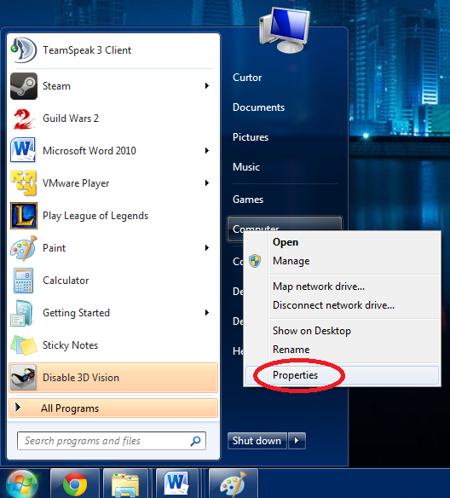1. Determine your PC architecture

Your home PC is either a 32 or 64 bit machine. If you already know what you have, skip to step 2.

First, open your computer’s properties. Click on the start menu, then right click on “Computer”, and then select “Properties.

Start > (Right click) Computer > Properties

If your computer runs Windows 8, the procedure will be the following:

(Right click) Start > System

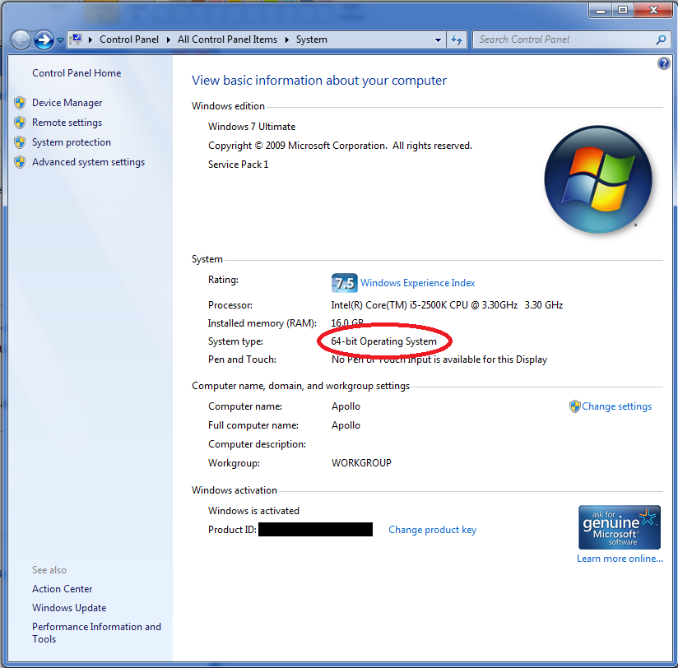

Next, you should see a window like the one to the right. Find the area that says “System Type” to find out your PC architecture.

The example is a 64 bit machine 🡪

*Note: If you use an Apple computer, you do not need to complete this step. Move on to Step 2.*

System Type: 64-bit Operating System

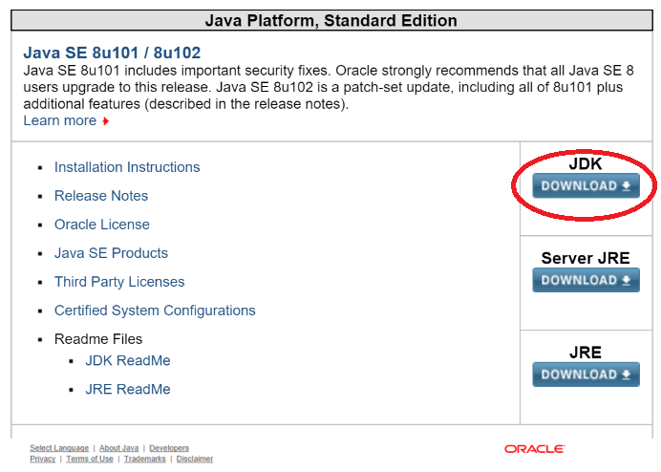2. Install Java

Go to the Java download website at <http://www.oracle.com/technetwork/java/javase/downloads/index.html>

Click the link that matches the type of computer you have, and follow the instructions.

3. Download Eclipse

Go to the eclipse website at <http://www.eclipse.org/downloads/eclipse-packages/>.

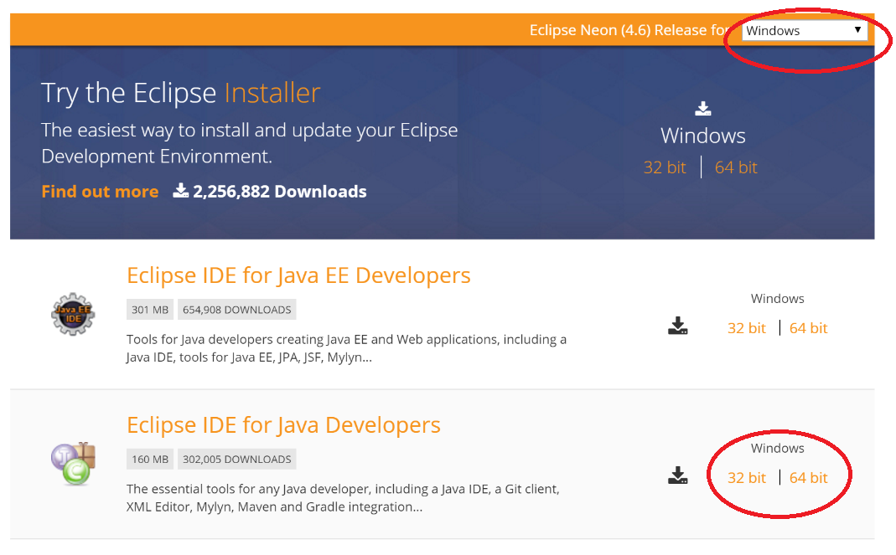In the navigation bar at the top of the website, click on select your operating system.

On the downloads page find “Eclipse IDE for Java Developers”. Click on the proper download link depending on your system’s architecture (determined in step 1).

**Note: Do NOT download “Eclipse IDE for Java EE Developers”.**

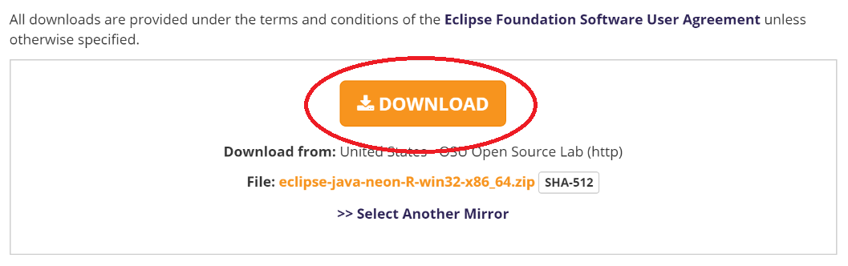On the next page, click the download link. (The download link may be a different location than “[United States] Georgia Tech Software Library, which is okay).

4. Run Eclipse

You should now have a copy of Eclipse, and all the material needed to run Eclipse, in a single compressed .zip file. Extract the contents of the compressed folder (right click on the .zip file > Extract All Here). Open the folder that was extracted and open eclipse.exe.

*Useful tip: Extract eclipse to the folder “C:\eclipse\”, or move it there after extracting it. You may wish to create a desktop shortcut to this location for convenience.*

You’re done! Whenever you want to run eclipse, run the eclipse.exe program.